**E. Rivers Elementary**

**Date: 8/30/23**

**Time: 4:30pm**

**Location: 1111**

1. **Call to order:** 4:35pm
2. **Roll Call**

|  |  |  |
| --- | --- | --- |
| **Role** | **Name** *(or Vacant)* | **Present or Absent** |
| **Principal** | **John Waller** | **Present** |
| **Parent/Guardian** | **Cason Given** | **Present** |
| **Parent/Guardian** | **Gregg Smolar** | **Present** |
| **Parent/Guardian** | **Khaki Janusz** | **Present** |
| **Instructional Staff** | **Keekwak Holloway** | **Present** |
| **Instructional Staff** | **Matthew Bryant** | **Present** |
| **Instructional Staff** | **Devon Rusert** | **Present** |
| **Community Member** | **Dr. Hersh Chopra** | **Present** |
| **Community Member** | **Marc Hardy** | **Present** |
| **Swing Seat** | **Megan Martinez** | **Present** |

**Quorum Established:** Yes

1. **Action Items** 
   1. **Approval of Agenda:** Motion made by: Smolar; Seconded by: Hardy

Members Approving: All

Members Opposing: 0

Members Abstaining: 0

**Motion** Passes

* 1. **Approval of Previous Minutes:** Motion made by: Smolar; Seconded by: Given

Members Approving: All

Members Opposing: 0

Members Abstaining: 0

* 1. **Fill Open Community Member Seat:**
     1. Dr. Hersh Chopra - community member; ophthalmologist & eye surgeon; ERES parent
     2. Motion made by: Smolar; Seconded by: Given
     3. Members Approving: All
     4. Members Opposing: 0
     5. Members Abstaining: 0
  2. **Fill Open Swing Seat**
     1. Megan Martinez - SLP at ERES; ERES parent
     2. Motion made by: Smolar; Seconded by: Hardy
     3. Members Approving: All
     4. Members Opposing: 0
     5. Members Abstaining: 0
  3. **Election of Officers and Representatives**
     1. Chair: Greg Smolar; all approve
     2. Vice-Chair: Matthew Bryant; all approve
     3. Secretary: Cason Given; all approve
     4. Cluster Representatives: Devon Rusert; all approve
  4. **Review and approve public comment protocol -** offer public comment 4x a year; sign up ahead of time; 20 mins max public comment; 2 mins allocated for each speaker; Smolar motion to approve; Given seconds; all approve
  5. **Set GO team meeting calendar**
     1. Meetings to take place at 4:30pm
     2. Aug. 30 (organizational mtg)
     3. Sept. 28*
     4. Oct. 25
     5. Nov. 29*
     6. Jan. 25
     7. Feb. 28*
     8. March 13
     9. April 24*
     10. *= open for public comment
     11. Smolar motion to approve; Hardy second; all approve
  6. **Review, confirm/update and adopt GO Team meeting norms**
     1. be present & respectful; follow agenda; be open-minded & curious
     2. Smolar motion to adopt; Holloway second; all approve

1. **Information Items**
   1. **Principal’s Report** ~ **strong start:** transportation (fully staffed; mostly running on time); new staff (12 new teachers); family engagement (record high attendance at open house; PTA volunteer training; PTA mtg well-attended); operations; **challenges**: volume of recent enrollments (>40 registrations since school started); schedule; tardies; parking (has improved recently but anticipate 2 yrs. of construction traffic); **instructional focus** involves APS5 (data, curriculum & instruction, signature programming, whole-child intervention, personalized learning)
   2. 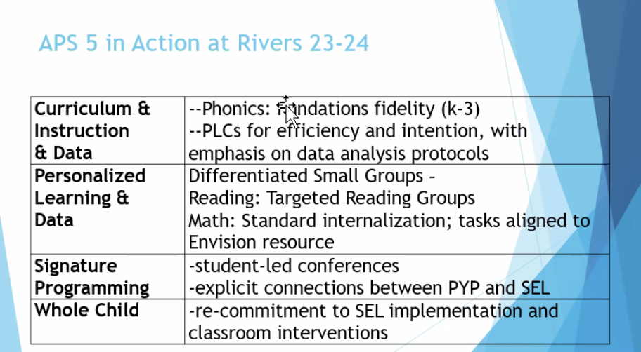
   3. 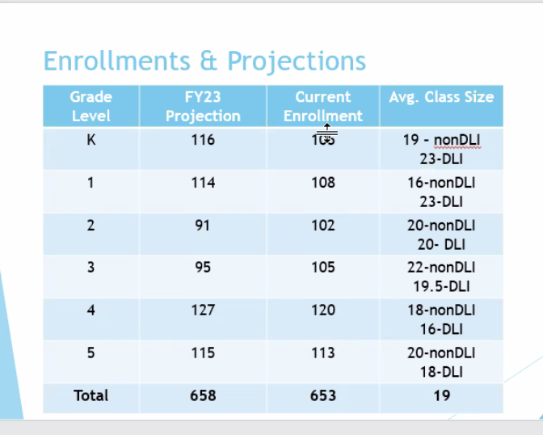
   4. 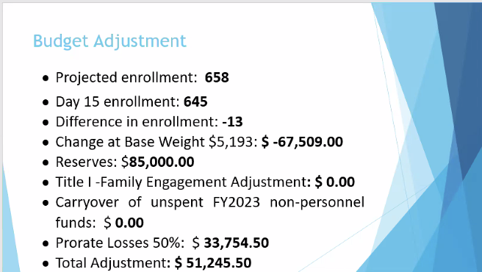
2. **Announcements**

**A. 2023 GO Team G3 Summit – Saturday, September 23 ~ optional**

**B. New GO Team Member Training and Orientation ~ online**

1. **Adjournment**

Motion made by: Smolar; Seconded by: Hardy

Members Approving: All

Members Opposing: 0

Members Abstaining: 0

**Motion** Passes

**ADJOURNED AT** 5:44pm

-----------------------------------------------------------------------------------------------------------------------------

**Minutes Taken By:** Cason Given

**Position:** GO Team Member

**Date Approved:** [Insert Date When Approved]